Open Mozilla Firefox and

1. Goto Tools -> Options

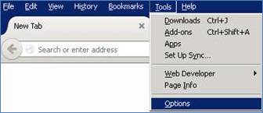

1. Goto Certificates Tab

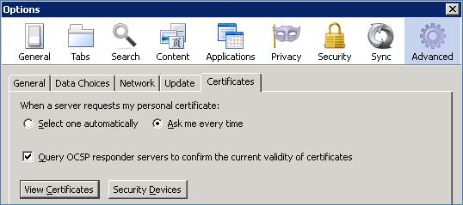

1. Click on ‘View Certificates’

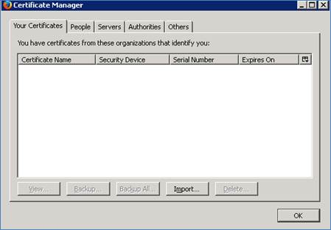

1. Click on ‘Import’ and Browse for the required Certificate to be installed and click on ‘Open’ button

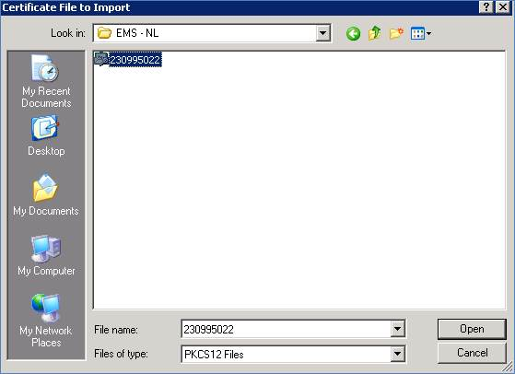

1. Enter password for the Certificate and then click on ‘OK’ button

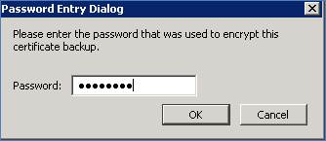

1. Restart Firefox (close the browser and open again) and then invoke IPG VT URL ()

Production Url :- <https://www4.ipg-online.com/vt/login>

UAT Test Url :- <https://test.ipg-online.com/vt/login>

1. it will display Certificate pop-up as below, select required Store certificate and then click on ‘OK’ button, it’ll redirect to VT-Login page
2. 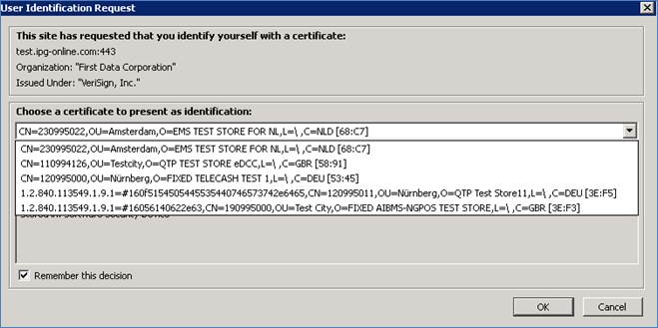
3. 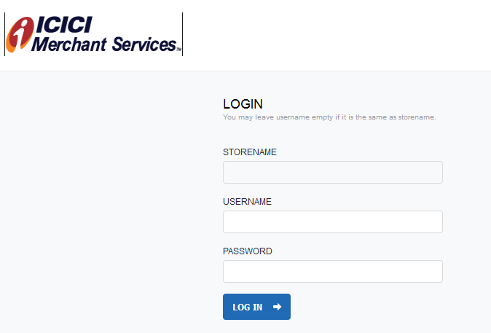After clicking OK button it should redirect to VT LOGIN page as shown below.